**Group 21: WordSearchGame Requirements**

**Introduction**

TheWordSearchGame (TWSG) is an online, multiplayer, competitive word search game. The game supports between 2-4 players and up to 5 concurrent games. Players go head-to-head against each other - competing to find words before the other players. The game ends when the time runs out, or when all the words are found. Player with the most points from finding words wins at the end of a game.  
  
User Interface  
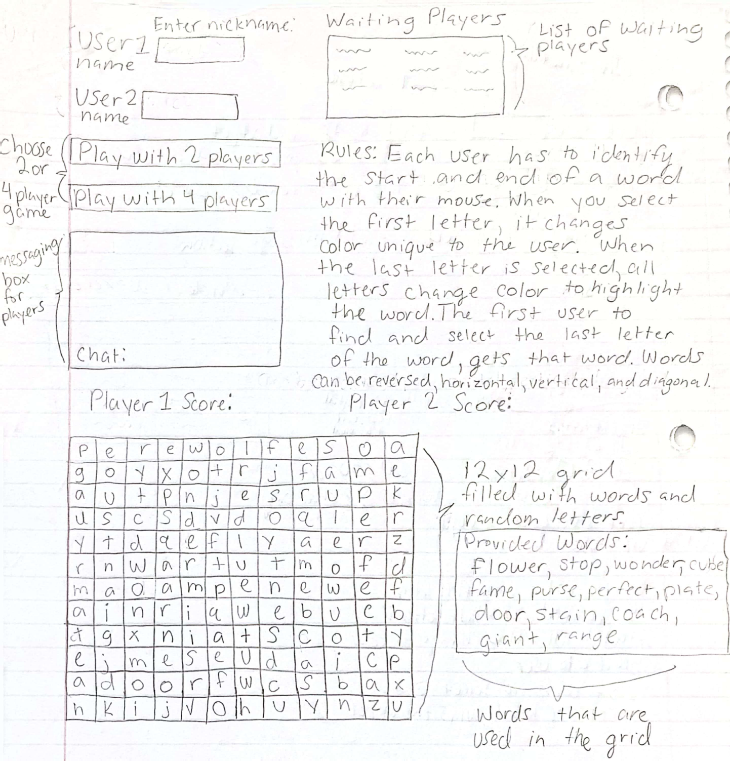 Use Cases**  
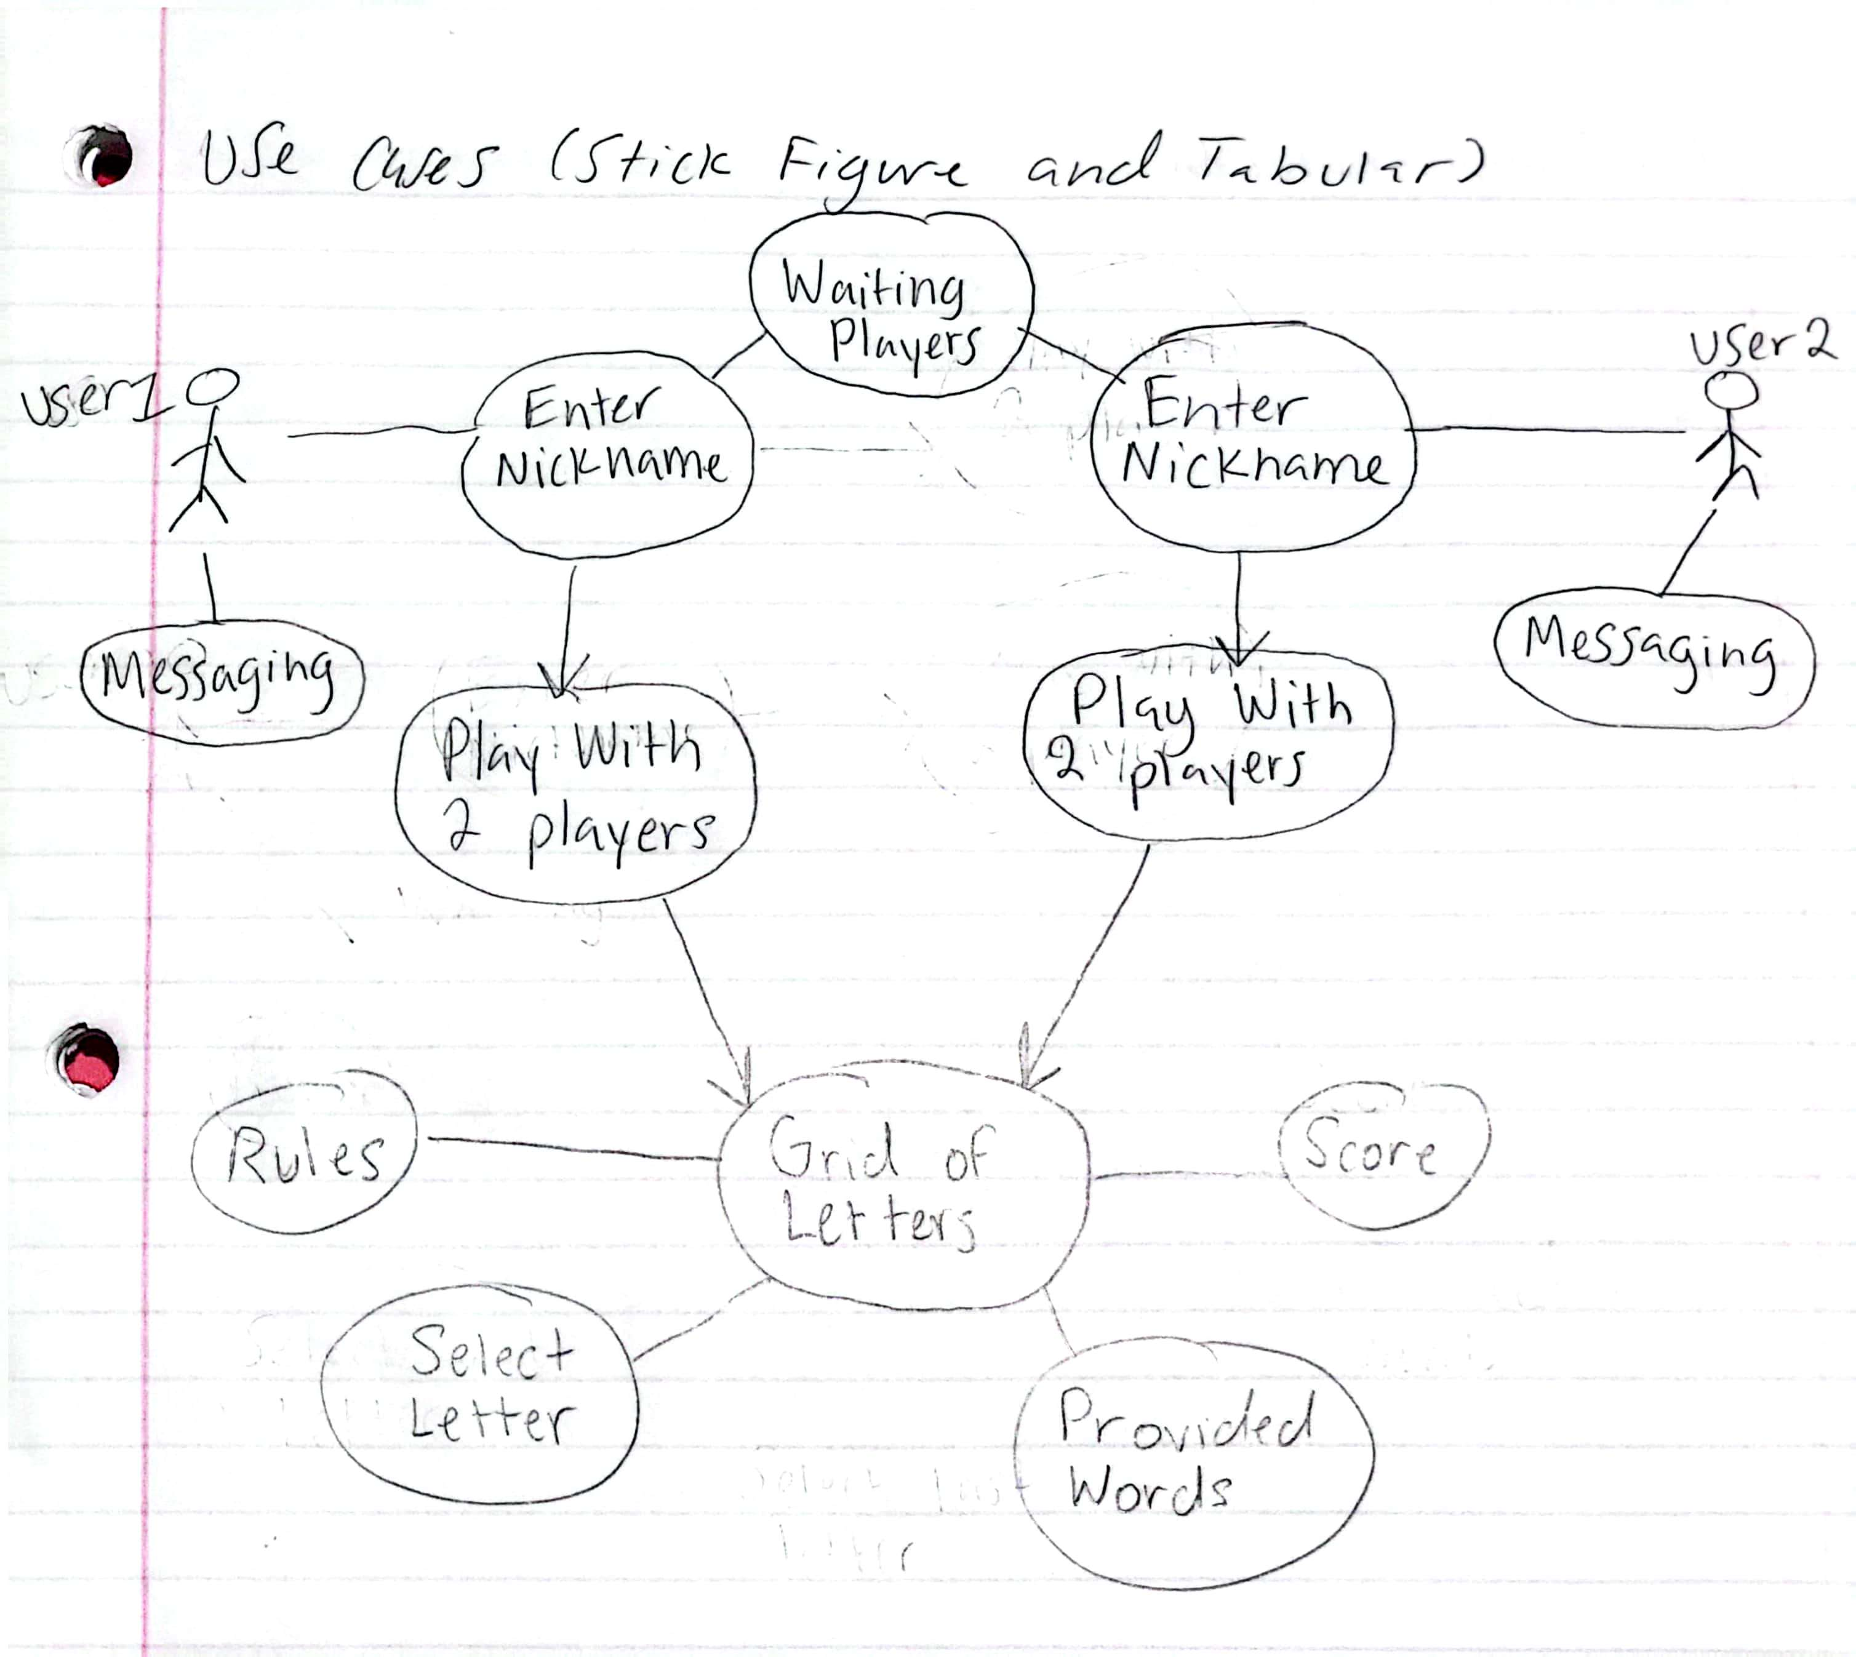**Unknowns** 1. What happens if a word is found within another word?